# Part 1 – Baseline

The baseline for the device is measured with only the Softdevice and no app flashed.

## Calculation

Nrf52 calculation:

* TDB

Device KX022

* high power mode 145 uA@2.5V
* low power mode 10 uA
* standby 0.9 uA

Device SHT3

* idle state 0.2 uA (max 2 uA)
* Average 2 uA while measuring w/lowest repeat.+single shot)

## Case 1: Softdevice flashed, no app flashed

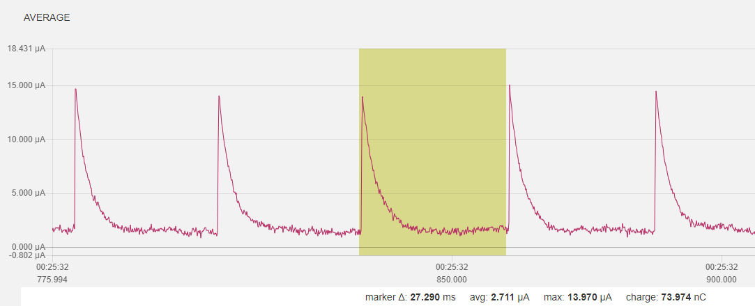

## Case 2: Softdevice, just go to idle mode

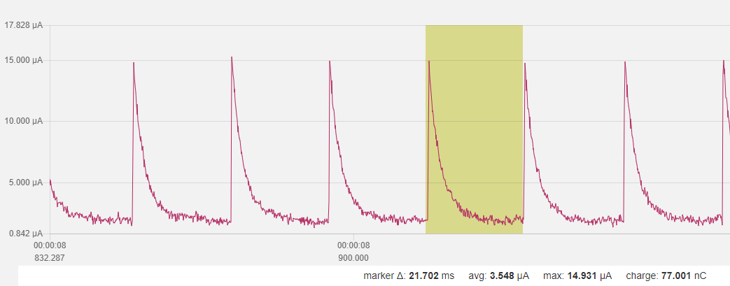

## Case 3: Softdevice, init bsp (led off), and just go to idle mode

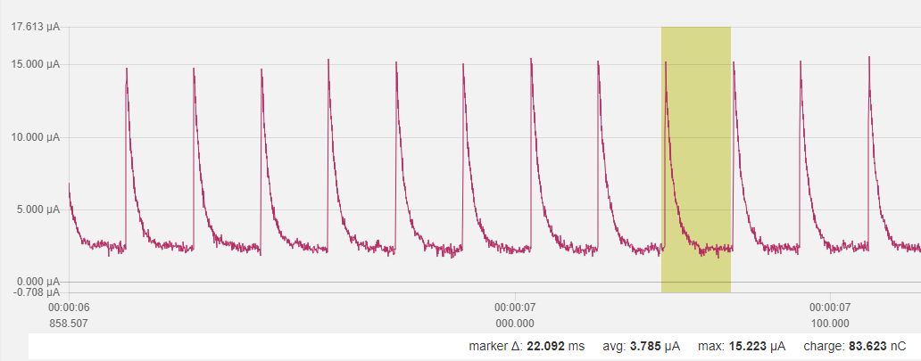

## Case 3b: as case 3 w/one led on

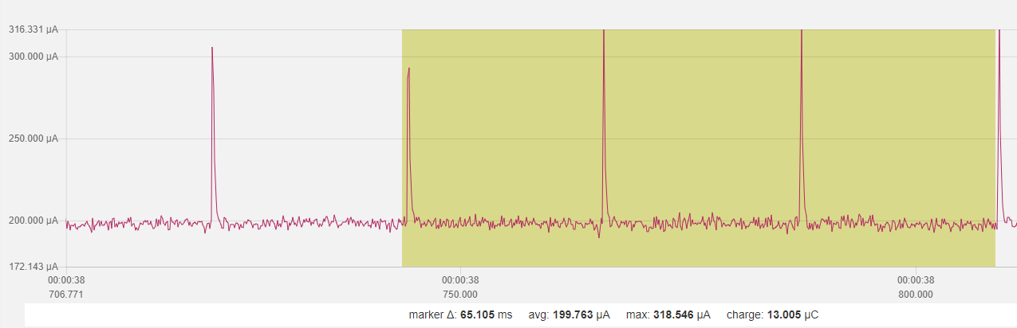

## Case 4: as case 3 (led off) + twi_config + (both) sensor_init

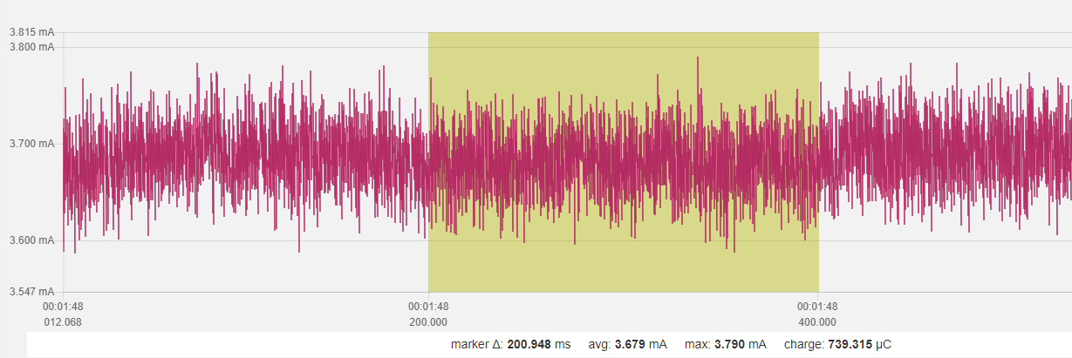

## Case 4a: as case 4 but no sensor_init

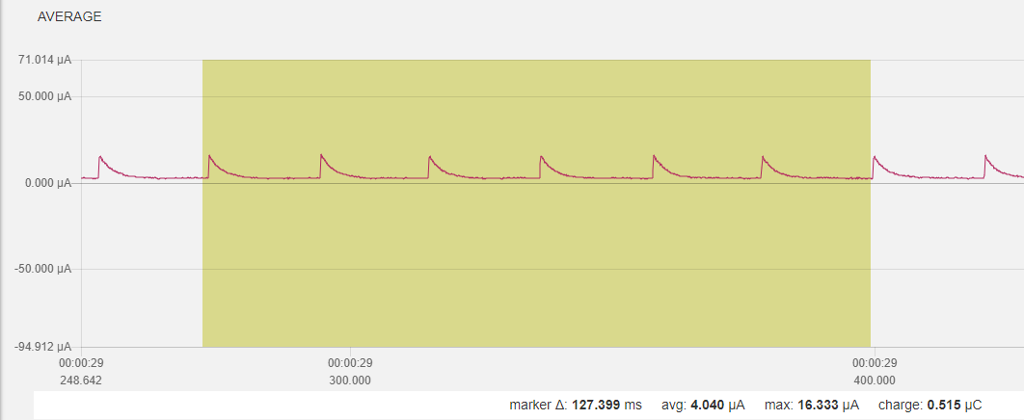

## Case 4b: only kx022 init

## Case 4c: only SHT3 init

## Case 5: as case 4c/SHT but no KX022, no sensor data + BLE adv

## Case 6: as case 5+ SAADC measurement)

## Case 6a: as case 6 w/o BLE init/adv

## Case 7: as case 5 + SHT measurement

## Case 8: all but KX022 measurement, 1/8 data acquisition for SHT and SAADC

## Case 8a

* reduce transmit power to 0dBm from +4dBm
* adv int to 1 sec from 1/10 sec
* SHT update int to 5 sec from 1/8 sec
* SADC update int to 10 sec from 1/8 sec

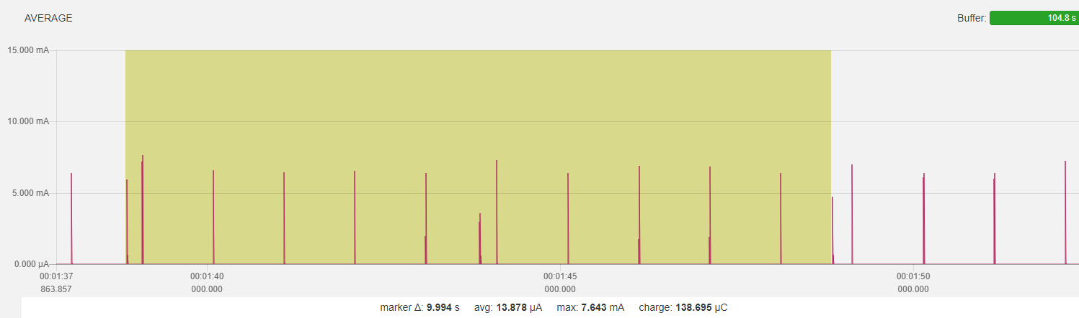

### Sensor update (all 5 sec)

### Adv (all 1 sec)

### Startup

* Peaks
  + Power on peak
  + First adv
  + First sensor acquisition

# Part 2 – Power Optimization KX022 Accelerometer

## Baseline, no BLE, no sensor init

## Change to TWI without transaction manager, SHT3 init and KX022 init to standby

## With KX022 and SHT3 “one shot” measurement, 1 Hz

### One measurement

Init KX022, Standby 1,2ms  
wait 1.2/ODR 3ms  
set to operate 0,5ms  
wait 1.2/ODR for value 3ms  
read accel values …  
SUM ~8ms

Set SHT3 to SHT3_MEAS_HIGHREP_STRETCH  
wait clock stretch 12,5ms  
read temperature and humidity 2,8ms  
SUM ~15ms

Process data and sleep again…  
Overall cycle 25ms, avg. power consumption 3,5mA, idle < 4uA

## Overall

### One 10sec cycle

### cycle

BLE 0 dBm, adv. interval 1s  
sensor (SHT3 and KX022) interval 5s  
SAADC (battery level) interval 10s  
overall power consumption ~30uA (28,77uA)  
idle power consumption 3,5uA

# Part 3 – Use RTC INT for while waiting for accel data

## Baseline

## Use RTC counter (freq 1/256) for KX022 “put to operation”, “wait for accel data”, and during SHT3 temp/hum measurement (w/max. 15ms time)

## one minute, analog to Part 2 overall

Optimization summary (Part 3 🡪 Part 4)  
BLE 0 dBm, adv. interval 1s  
sensor (SHT3 and KX022) interval 5s  
SAADC (battery level) interval 10s  
overall power consumption ~30uA (28,77uA) 🡪 17,68uA   
idle power consumption 3,5uA 🡪 3,5 uA

# Part 4 – Further optimization

### Using nested approach: start long running SHT3 first, complete KX022 tasks and read SHT3 values **KX022: ODR 1600 -> delay time 3ms**

### one minute, analog to Part 3 overall

thus, no real further improvement

### **KX022: ODR 200 -> delay time 7ms**

### one minute, analog to Part 3 overall

thus, no real further improvement

## Longer intervals between adv and samples

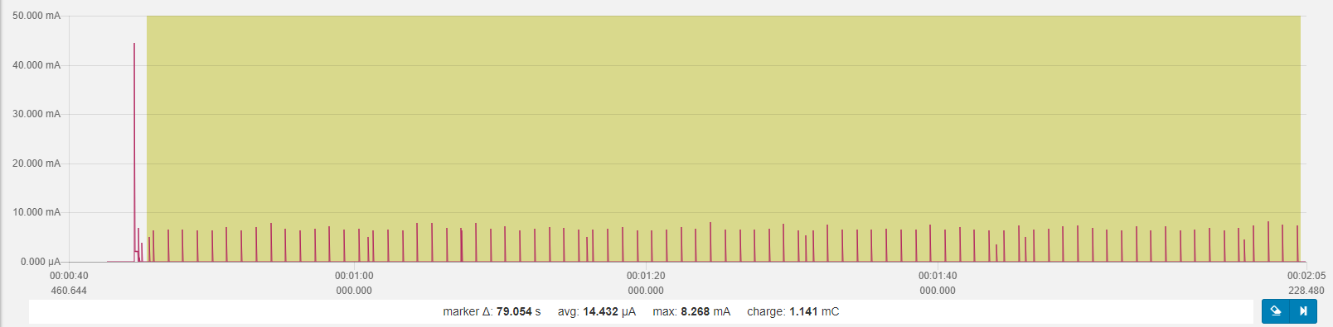BLE 0 dBm, adv. interval 1s  
sensor (SHT3 and KX022) interval 15s  
SAADC (battery level) interval 60s  
overall power consumption 14,4uA   
idle power consumption 3,6 uA

220mAh / 0,0144mA * 0,7 = 10.694 h = ~1.2 Jahre

(> 1 Jahr = 365*24h = 8760h; CR2032 = 220 mAh)

Button functionality introduced

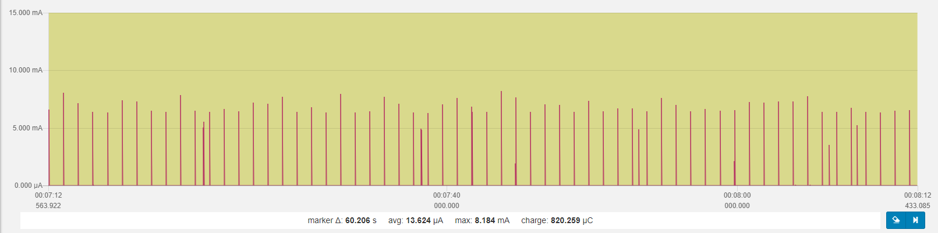

Single button press  
